**DATA MINING LAB ASSIGNMENT – 1**

**GERMAN CREDIT DATASET:-**

**OBSERVATIONS:-**

The german_credit dataset classifies people to either good or bad credit risks.

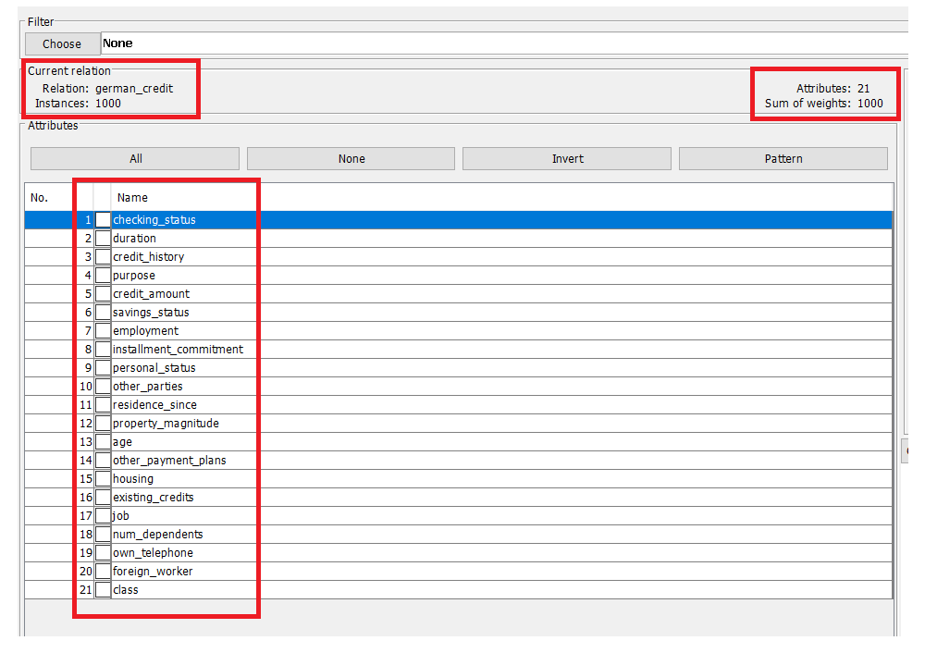

**Number of records, attribute names and types:-**

The german credit dataset consist of 1000 records with 21 attributes.

|  |  |
| --- | --- |
| **Attribute Name** | **Attribute Type** |
| checking_status | Nominal |
| duration | Numeric |
| credit_history | Nominal |
| purpose | Nominal |
| credit_amount | Numeric |
| savings_status | Nominal |
| employment | Nominal |
| Installment_commitment | Numeric |
| Personal_status | Nominal |
| Other_parties | Nominal |
| residence_since | Numeric |
| property_magnitude | Nominal |
| age | Numeric |
| other_payment_plans | Nominal |
| housing | Nominal |
| existing_credits | Numeric |
| job | Nominal |
| num_dependents | Numeric |
| own_telephone | Nominal |
| foreign_worker | Nominal |
| class | Nominal |

**Class attribute in the dataset:**

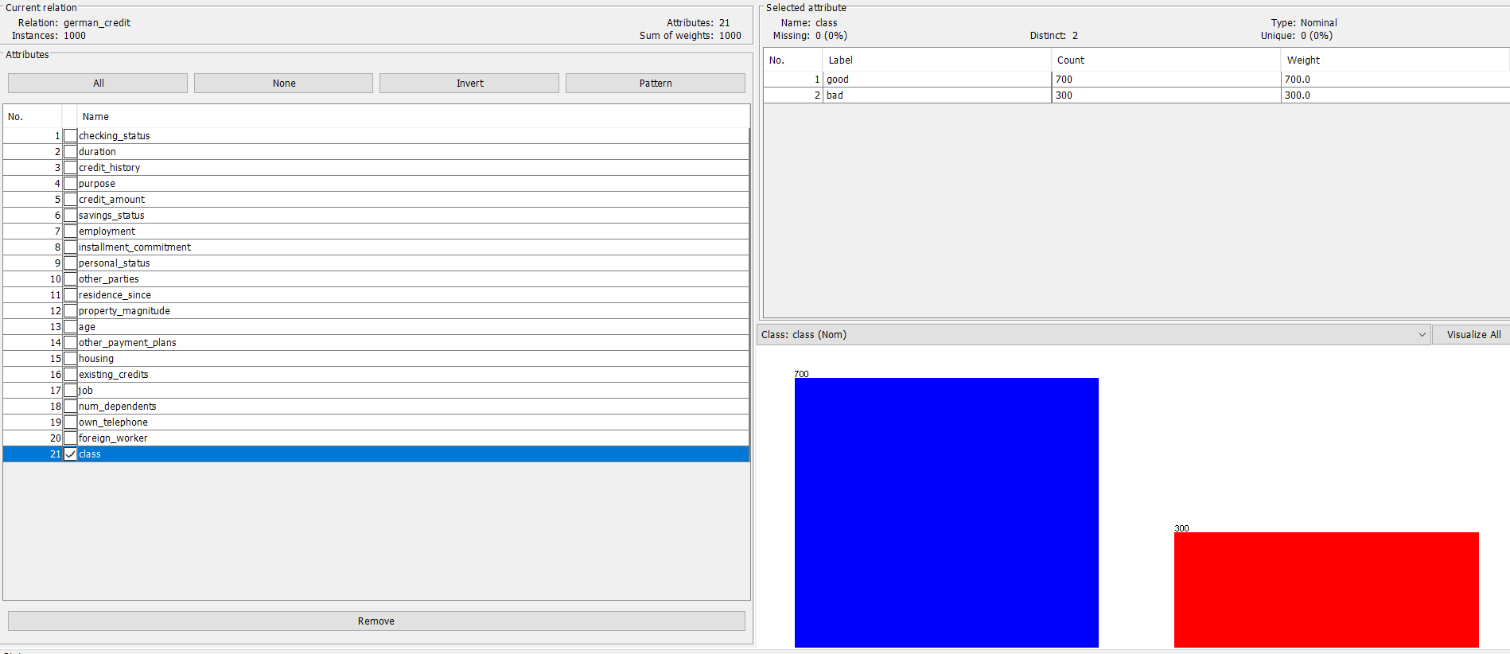

**Number of records for class:**

Good – 700

Bad – 300

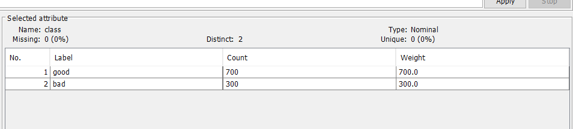

**Plot histogram:-**

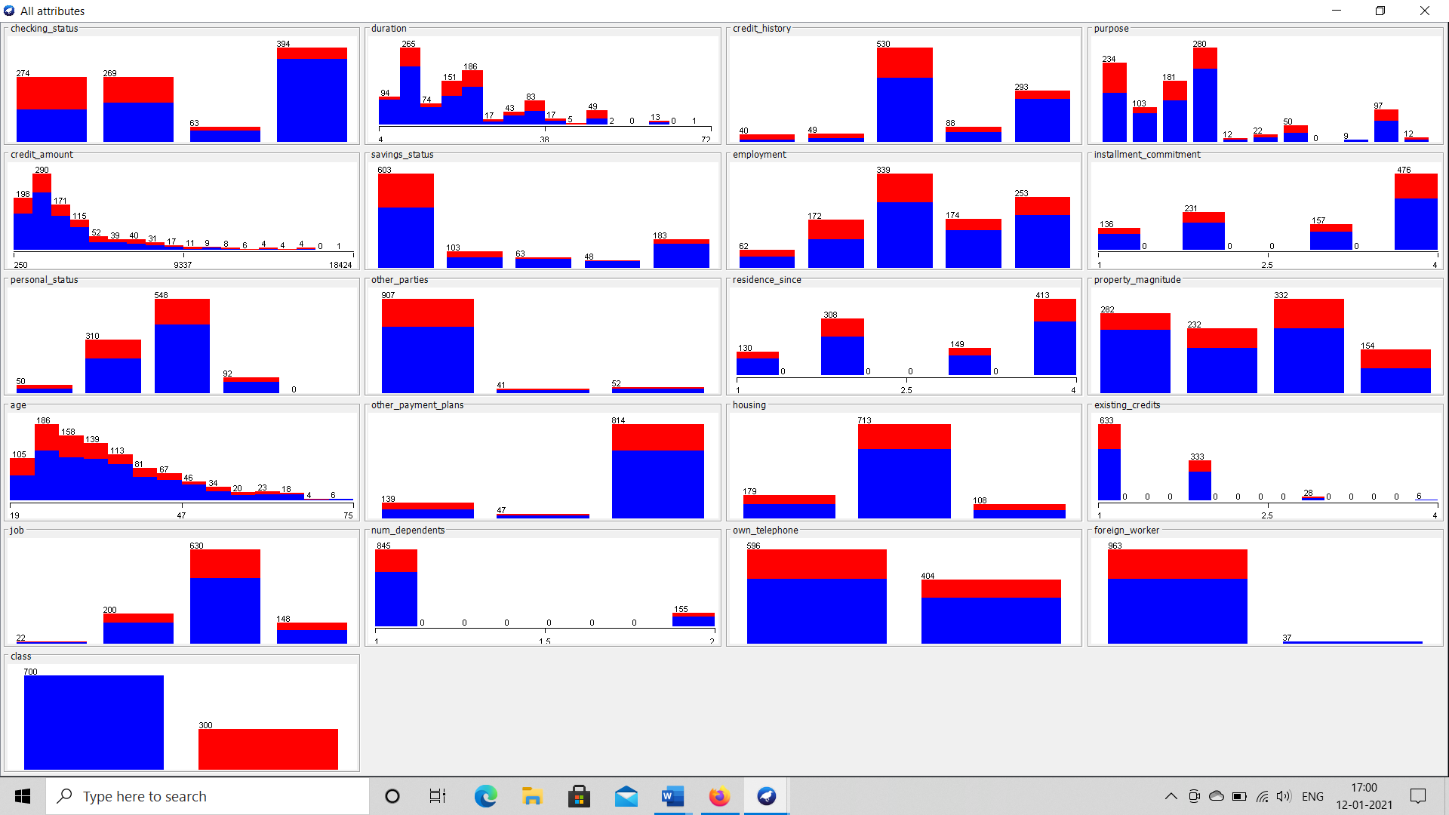

Blue colour represents good and red colour represents bad class.

**IRIS DATASET:-**

**OBSERVATIONS:-**

It is a dataset through which we classify flowers into 3 categories.

**Number of records, attribute names and types:**

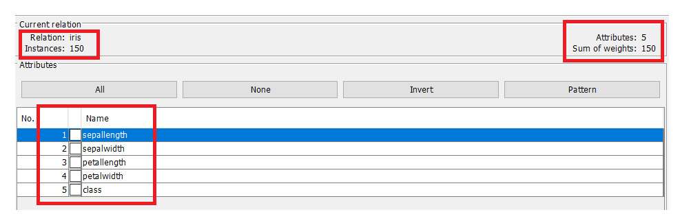

The iris dataset consists of 150 records with 5 attributes.

|  |  |
| --- | --- |
| **Attribute Name** | **Attribute Type** |
| sepallength | Numeric |
| sepalwidth | Numeric |
| petallength | Numeric |
| petalwidth | Numeric |
| class | Nominal |

**Plot Histogram:**

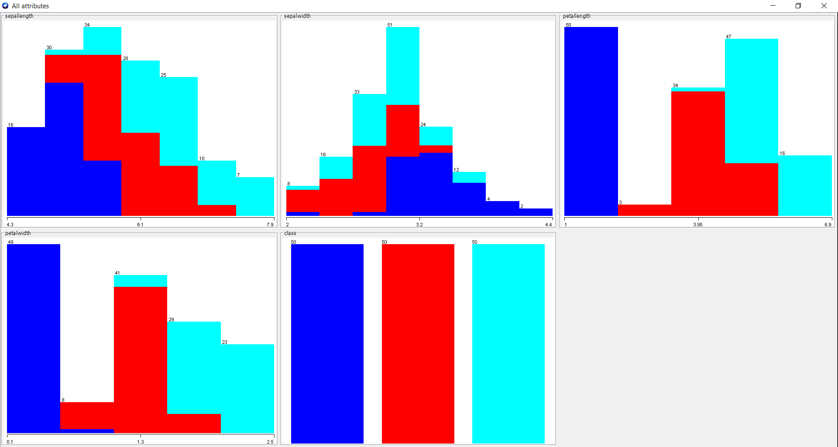

There are 3 classes in the dataset. Where blue represents Iris-setosa, red represents Iris-versicolor and light blue represents Iris-virginica.